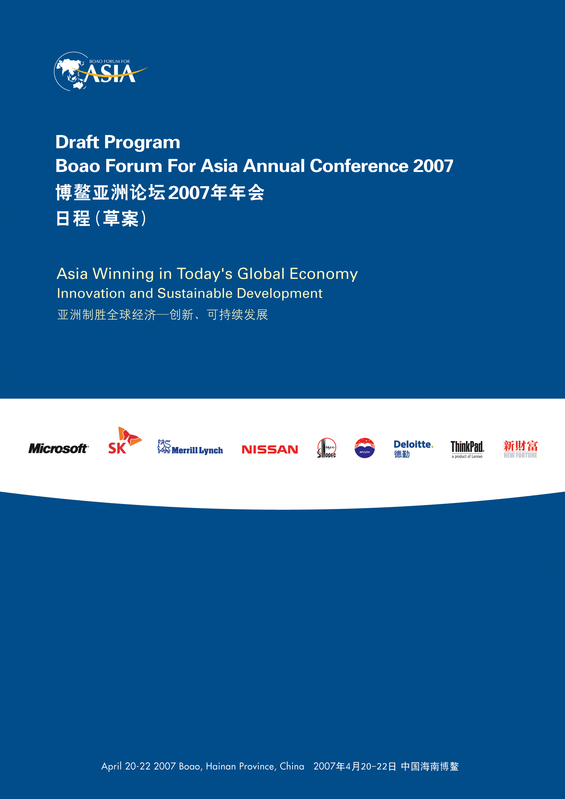
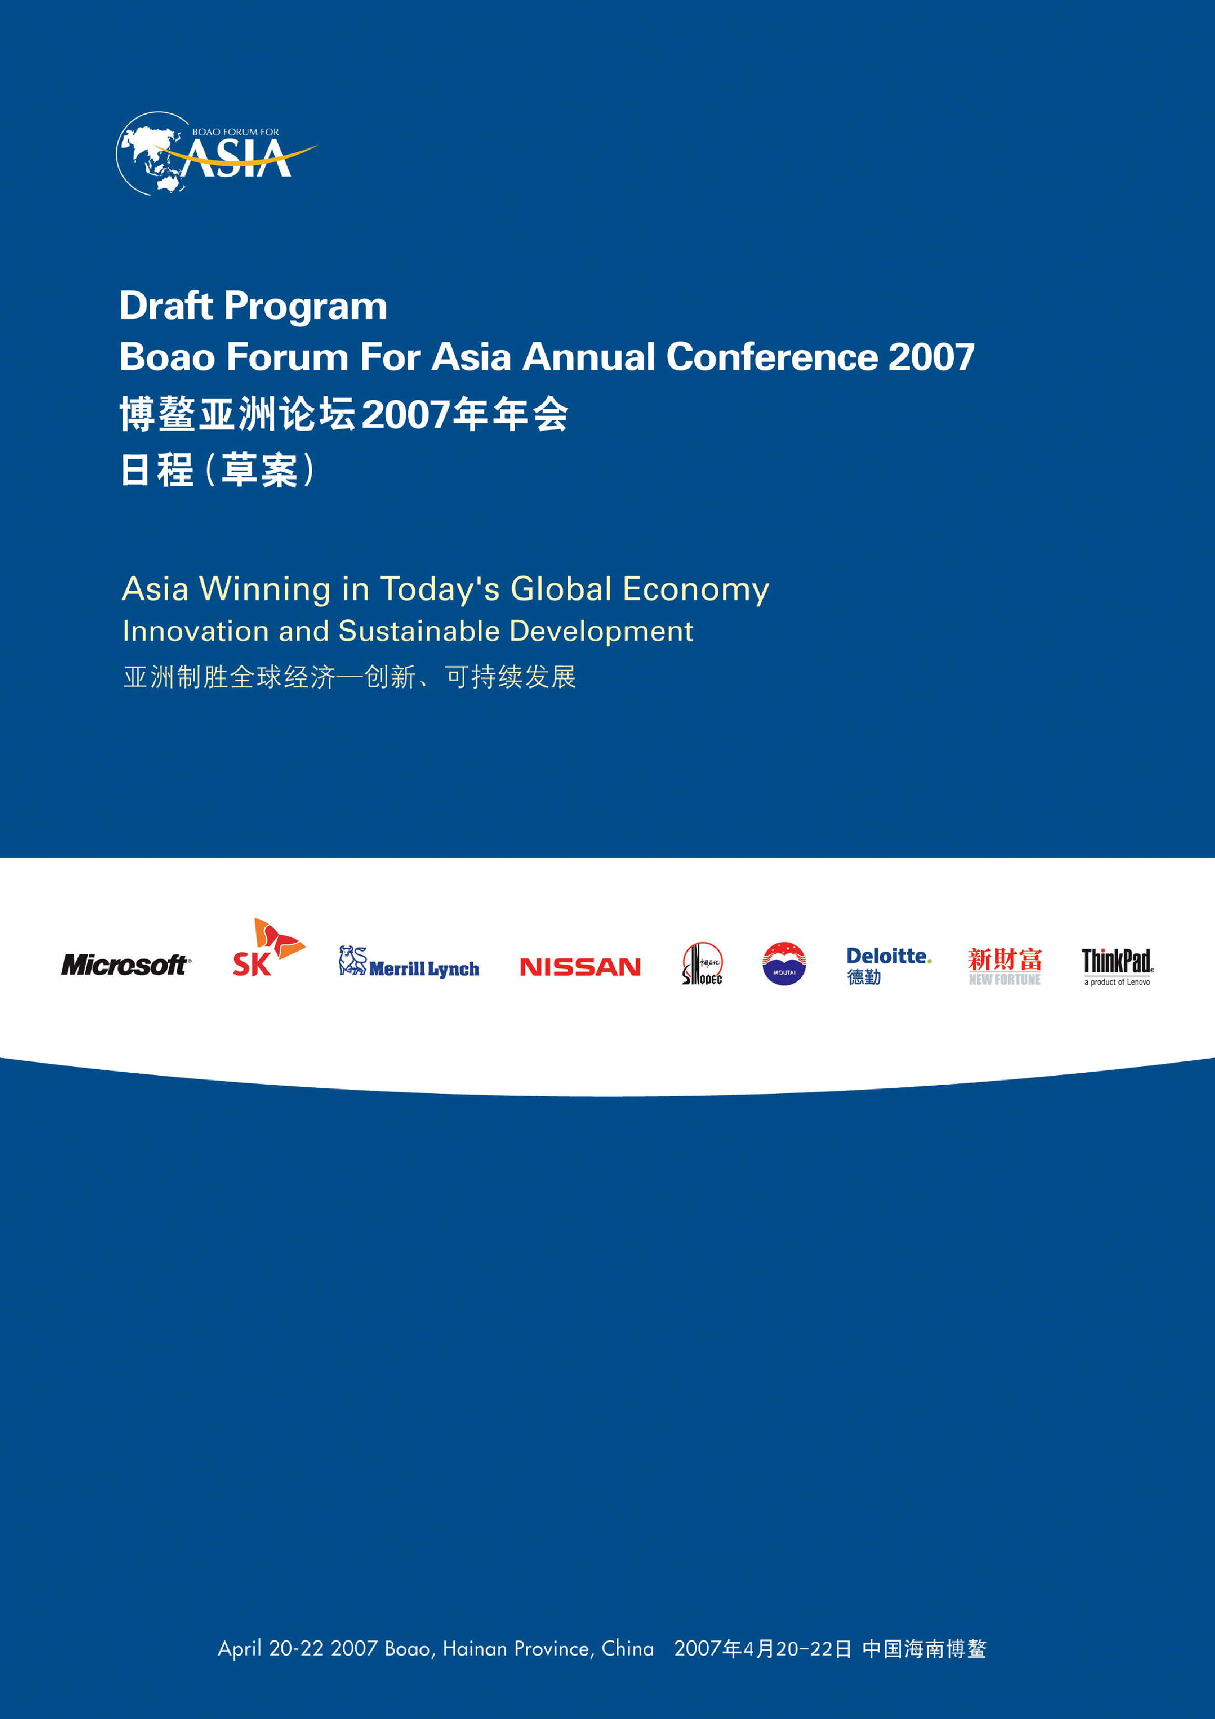
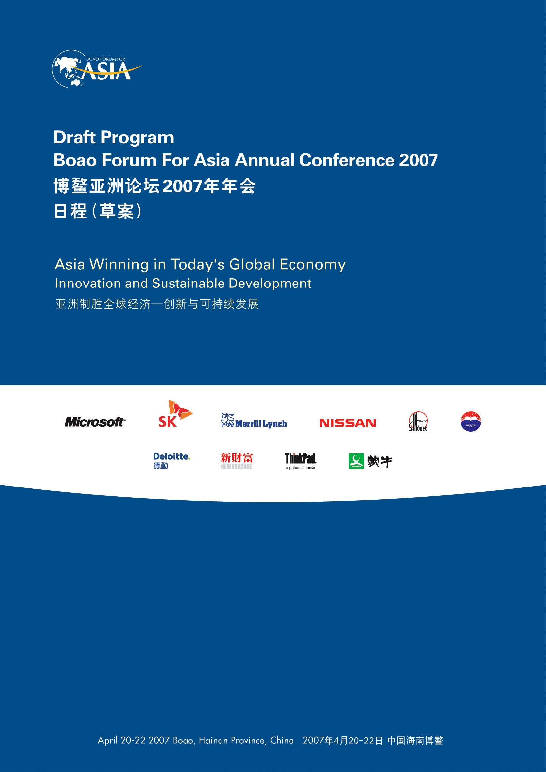


Thursday, April 19

07:00 - 22:00 | Registration
 | (Meilan Airport, Haikou)
15:00 - 16:00 | BFA Board of Directors Meeting (I)
 | (Sofitel Club, 5th Floor, Sofitel Hotel)
16:30 - 18:00 | General Meeting of BFA Members
 | (Dong Yu Grand Ballroom A, Level 1, ICC)
18:00 - 19:00 | BFA Board of Directors Meeting (II)
 | (Peacock I, Level I, ICC)
19:00 - 20:30 | Welcome Dinner for BFA Members and Sponsors
 | (Symposium Restaurant, 1st Floor, Sofitel Hotel)
 | (Sofitel Club, 5th Floor, Sofitel Hotel)

Friday, April 20

07:00 - 22:00 |  | Registration
 |  | (Meilan Airport, Haikou)
07:00 - 14:00 |  | BFA Golf Invitational 2007
 |  | (BFA ICC Golf Club, Dong Yu Island)
15:00 - 15:30 |  | BFA AC 2007 Press Conference
 |  | (Oriental Theatre, 1st Floor, Sofitel Hotel)
16:00 - 18:00 |  | 21st Century Leaders Roundtable---  What Asia do We Want to Create for Future Generations?
 |  | (Dong Yu Grand Ballroom A, Level 1, ICC)
Co-Chairpersons: Michael JOHNSON, Member of Parliament, Australia
Songyee YOON, Vice President, SK Group
18:00 - 19:00 |  | Welcome Cocktail
 |  | (Foyer, BFA Main Hall, Level 2, ICC)
18:00 - 19:00 |  | Cocktail Reception Hosted by SK Group
 |  | (Invitation Only, Pavilion, 2nd Floor, Sofitel Hotel)
19:00 - 20:30 |  | Welcome Dinner Hosted by the People’s Government of Hainan Province
 |  | (BFA Main Hall, Level 2, ICC)
20:45 - 22:15 |  | Green Agenda for Real Estate Industry
 |  | (Dong Yu Grand Ballroom A, Level 1, ICC)
With rapid economic growth, real estate is also catching up quickly in Asia. However, the high-waste, high-energy-consumption and high-pollution approach to real estate development has brought about enormous pressures on environment and energy and run counter to the strategy of sustainable development and social harmony. The government encourages and the public aspires for the Green Real Estate featuring renewable energy, energy-saving, water-saving, raw-material-saving and environment-friendliness. Nonetheless, real estate developers, for their part, care more about the commercial viability and technology-readiness of the Green Real Estate while taking on corporate social responsibilities. Commercially unviable Green Real Estate is not sustainable itself. Can Green Real Estate generate enough economic returns so as to satisfy all parties concerned: the government, the public and real estate developers? Are technologies ready? What policy incentives have or will the government put in place to encourage the Green Real Estate?
Renovation of old cities, construction of new cities and urbanization of rural areas undoubtedly contribute to the rapid growth of real estate. Massive tear-down of old buildings to give way to blocks after blocks of modern skyscrapers has been condemned. However, how to preserve historic buildings, achieve the harmony of old and new buildings and protect the unique cultural and historical identity of a city remains a major challenge to the real estate industry. Have Asian countries identified some successful models in this aspect? What experiences/lessons can they learn from advanced countries?
Moderator: PAN Shiyi, Chairman, SOHO China Ltd.
Panelists: REN Zhiqiang, President, Beijing Hua Yuan Group
MA Yansong, Chief Architect, MAD Ltd.
Maria KO, President & CEO, Mako Group
21:00 - 24:00 | Merrill Lynch Annual Cocktail Party
 | (Lobby Bar, 2nd Floor, Sofitel Hotel)

Saturday, April 21

09:00 - 10:45 | Official Opening
 | (BFA Main Hall, Level 2, ICC)
 | Chairman: LONG Yongtu, Secretary General, Boao Forum for Asia
Welcome Remarks:
Fidel V. RAMOS, Chairman, Board of Directors, Boao Forum for Asia,
Former President of the Philippines
CHEY Tae Won, Chairman, SK Group
 | Keynote Speakers:
Gloria Macapagal ARROYO, President, the Philippines
Shaukat AZIZ, Prime Minister, Pakistan
Bill GATES, Chairman, Microsoft Corporation
Muhammad YUNUS, Nobel Prize Laureate; Founder of Grameen Bank, Bangladesh
WU Bangguo, Chairman, Standing Committee of the National People’s Congress, People’s Republic of China
10:45 - 11:00 | Break
11:00 - 12:30 | Accelerating Asian Growth: Evolution of the Asian Economic Community
 | (Dong Yu Grand Ballroom A, Level 1, ICC)
Given the scenario of stalled Doha Round of trade negotiations and the changing landscape of regional trading agreements in Asia, what is next for multilateral trading systems and its implications in Asia? Moreover, what is the current status and prospects of Asian economic integration? Will the enhanced cooperation of Asian countries progress towards a more cohesive and integrated region, and will give way to building of an Asian Economic Community? How will it affect overall growth in the region? Furthermore, what will be the expectations and role of the business sector in deepening and broadening cooperation and integration?
Moderator: C. Lawrence GREENWOOD, Vice President, Asian Development Bank
Panelists: LIM Hng Kiang, Minister for Trade and Industry, Singapore
Warren TRUSS, Minister for Trade, Australia
Hee-Beom LEE, Chairman, Korea International Trade
Association
Victor FUNG, Chairman, the Li & Fung Group
TAKAGI Michiyo, Parliamentary Secretary for Economy, Trade and Industry （Vice Minister, METI）
11:00 - 12:30 Energy and Resources: New Approaches to Collaborating towards
Energy Security in Asia
 | (Dong Yu Grand Ballroom B, Level 1, ICC)
Collectively, the Asia-Pacific region consumes much more energy than it produces. It represents 29% of global oil demand yet supplies only 10%. Moreover, driven by economic growth, future energy demand in the region will only accelerate. Achieving energy security is therefore critical for the entire region. This panel will discuss questions such as: Can the region collaborate to become owners of supply by purchasing oil and gas assets? What can government and businesses do to extend the lifespan of existing conventional energy sources? Technology in use today is 10-30% less efficient than the best available technology; can Asia “leapfrog” in innovation and adoption of energy-efficient technologies? What must governments and businesses do to encourage continual development and deployment of renewable energy sources such as hydro, wind, solar, tide, and marsh gas? What roles can the major Asian economies play?
Moderator: Christopher G. NICHOLSON, Global Leader, Energy & Resources, Deloitte
Panelists: CHEN Deming*, Vice Chairman, National Development and Reform
Committee, PRC
FU Chengyu, President, CNOOC
Gary LOCKE, Former Governor of the State of Washington, USA
Rob MORRISON, Chairman & CEO, CLSA Ltd.
KIM Tai Yoo, Professor and Chair Professor of Techno-Economics
(ENG), Seoul National University
12:45 - 14:30 | Luncheon Session
 | (Dong Yu Grand Ballroom C & D, Level 1, ICC)
 | Keynote Speaker: BO Xilai, Minister of Commerce, China
15:00 - 16:00 | Corporate Social Responsibility and Achieving Inclusive Growth
(BFA Main Hall, Level 2, ICC)
Asia’s economic growth has been nothing short of remarkable. And that growth has raised important and complex questions about what it require to sustain it over the long term. Issues such as poverty, health care, education, or even the provision of basic necessities like clean water were once thought to be the strict province of governments and not-for-profit organizations. However, for companies doing business in Asia to deliver the growth that global investors demand, their business leaders must now balance short-term business needs while seeking solutions to there broader challenges. Is it possible to do both? What does “corporate social responsibility” mean for governments, NGOs and domestic and multinational companies; and what roles should each play? Is there a role for innovation in addressing issues such as poverty, health care and the lack of infrastructure? What are the commercial possibilities of solving some of the challenges? And what are the long-term implications for Asian businesses if these challenges are not adequately addressed today?
Moderator: Nik GOWING, Presenter and Anchor, BBC
Panelists: Muhammad YUNUS, Nobel Prize Laureate; Founder of Grameen Bank, Bangladesh
William PARRETT, Global CEO, Deloitte
WEI Jiafu, President & CEO, COSCO Group
Jim DONALD, President & CEO, Starbucks Coffee Company
CHEUNG Yan, Chairman, Nine Dragons Paper (Holdings) Ltd.
16:00 - 16:30 | Break
16:30 - 18:00 | Pakistan: Transregional Hub, Linking Asia to the Middle East and Beyond.
 | (Dong Yu Grand Ballroom A, Level 1, ICC)
Pakistan is in a unique position, geographically and socially, to be a key link between Middle East and Asia. Its economy is expanding rapidly, and its policymakers have in the past few years created an environment within which the private sector has begun to flourish. These policy measures include substantial privatization, reforms in the banking and utility sectors and efforts to streamline interactions with the government. To realize its potential to play a key role in the region, Pakistan continues to address challenges associated with rapid growth by improving its social infrastructure, increasing development spending, and attracting more foreign investment. It is fast emerging as a manufacturing and servicing hub. Pakistan is also taking major strides to realize its full potential as a trans-regional hub by developing multiple corridors of cooperation in the energy, trade, transportation and financial sectors.
Chairman: Bob HAWKE, Member, BFA Board of Directors
Honorary Guest: Shaukat AZIZ, Prime Minister, Pakistan
Panelists: CHEN Yuan*, Governor, China Development Bank
ZHANG Hongbiao, General Manager, China Aviation Industry Corporation II
Amr Abdullah M.A. Al DABBAGH, Governor, Saudi Arabian General
Investment Authority
YAN Jiehe, Chairman, China Pacific Construction Group Co., Ltd.
16:30 - 18:00 | Asian Values: The Success of Asian Global Enterprises
 | (Dong Yu Grand Ballroom B, Level 1, ICC)
The increasing eminence of Asian companies in the global arena is a fact. 122 out of the Global Fortune 500 are companies from Asia in 2006. Japan, Korea and China are amongst the top 5 in patent filings—an indicator that Asia is a significant source of innovation. Japan and Korea, in particular, have been successful in building global enterprises. What can the rest of Asia learn from them? How have these companies themselves been so successful in strategizing, innovating and managing risks to become a global force? How can Asian companies leverage the Asian spirit and values—such as respect for tradition, craftsmanship and design, entrepreneurialism, emphasis on relationships—to create differentiated core competencies which will help them sustain their competitive edge and adapt to their ever evolving environment?
Moderator: Stephen ENGLE, Reporter, Bloomberg Television
Panelists: Rick TSAI, President & CEO, TSMC
Charles WRENCH, President & CEO, Landor
YANG Wenjun, President, Mengniu Dairy (Group) Co., Ltd.
Mark FULLER, Chairman & CEO, Monitor Group
19:00 - 20:30 | Charity Dinner Party and Fireworks
 | (Swimming Pool Area, Golden Coast Hot Spring Hotel)
21:00 - 22:30 | Mengniu Cocktail Reception
 | (Boao Kempinski Hotel)

Sunday, April 22

09:00 - 10:30 |  | India, China and Asia: Establishing a Symbiotic Relationship
 | (Dong Yu Grand Ballroom A, Level 1, ICC)
It is hard to refute that the rise of China and India has drawn the spotlight on the rest
of Asia. However, as the rise of China and India has changed and often challenged
the role many Asian businesses play on the global stage, how are Asian countries
reinventing themselves, updating their relevance, and redefining their relationships
with China, India and the rest of the region? Can a symbiotic relationship exist between
China, India and the rest of Asia, whereby all countries gain to benefit? Can it be
assumed that Asian countries are in a unique position to benefit from the advancements
being made in China and India? If so, how can other Asian countries and markets
leverage the successes of China and India, or learn from them? Similarly, what benefits
could China and India enjoy from strong business relations with other Asian countries?
Moderator: Christopher GRAVES, CEO, Asia Pacific, Ogilvy
Panelists: Habil KHORAKIWALA, President of FICCI
Alan ROSLING, Executive Director, Tata Sons
Robert R. MORSE, CEO, Asia Pacific Corporate and
Investment Bank, Citigroup
Kenneth A TOROK, President, UPS Asia Pacific
LIN Yifu*, Founder and Director of the China Center for Economic
Research, Peking University
09:00 - 10:30 | Power of Media and a Harmonious Asia
 | (Peacock I, Level 1, ICC)
The power of media is never to be underestimated. Its impact on cultural heritage,
social values and the modernization drive of a country is vital. Regretfully, two-thirds
of the information flow on the global media is sourced from developed countries
which account for no more than one-seventh of the world’s population. 60% of the
information on various newspapers in developing countries originates from developed
countries. Voices of Asian countries are much less heard globally than their due. In
order to foster a favorable climate for a harmonious Asia, what social responsibilities
should the Asian media take up? What role should Asia play in the integration of
global media? What implications will the global media integration have on Asian media?
Moderator: ZHU Yinghuang, Honorary Editor-in-Chief, China Daily
Panelists: Ravindra KUMAR, Editor and Managing Director, The Statesman, India
LIU Jiang, Vice Chief Editor, Xin Hua News Agency
SAEYOON Suthichai, Group Editor-in-Chief, The Nation, Thailand
Felix SOH, Deputy Editor, The Straits Times
Mahfuz ANAM, Editor-in-chief and Publisher, The Daily Star
LI Xiguang, Executive Dean of the School of Journalism and
Communication of Tsinghua University
10:30 - 11:00 | Break
11:00 - 12:30 | Universal Banking: The Next Innovation and Boost to Asia’s Global Growth
 | (Dong Yu Grand Ballroom A, Level 1, ICC)
On December 11, 2006, China fulfilled its WTO commitments to
open its banking sector, probably the most significant development
in recent times in the global banking industry. With the removal of
geographic restrictions, foreign banks can now tap any part of China
that they want and, in turn, China’s domestic banks consequently,
inevitably and increasingly will be galvanized to make service enhancements
and increase their competitiveness. How can Chinese banks leverage
their existing infrastructure to build a new competitive advantage?
How can foreign banks leverage the expanded operating scope provided
by the new regulations? How will the market opening influence alliances
between local and foreign banks?
Moderator: HU Shuli, Editor, CAIJING, Magazine
Panelists: Kevan WATTS, Chairman, Merrill Lynch International Inc.
LI Jiange, Vice Minister, Development Research Center of State Council, PRC
ZHU Min, Vice President, Bank of China
FAN Gang, President, Institute of National Economy
11:00 - 12:30 | Convergence & Divergence in Telecommunications, Media and Technology :  the Opportunity for Asia
 | (Dong Yu Grand Ballroom B, Level 1, ICC)
The convergence of telecommunications, media and technology (TMT) has been
predicted for many years. Such convergence is progressing differently and at
varying speeds depending on the individual market conditions. For instance,
Japan and Korea are considered leaders in the region and globally; while China
with the largest mobile and internet subscriber base in the world is on a rapid
adoption curve, fueled by technology advancements. At the same time,
divergence is a key force in achieving success; creating a simpler, more
focused product or service offering is often the best route to market adoption.
The combination of convergence and divergence creates a powerful platform
for innovation -- it is, therefore, imperative for every TMT executive to develop
a clear strategy for capitalizing on these trends. Panelists in this session will
address questions such as: How will telecommunication service providers
change how business is conducted, ensure the environment is preserved and
quality of life improved in Asia? What kinds of investment in technological
infrastructure must Asia undertake to keep pace with and drive the rapid
rate of change? How can businesses and government partner ensure more
Asian citizens to have access to the Internet and to advanced broadband technologies?
Moderator: Robert CHIU, Managing Director, Merrill Lynch (Asia Pacific) Ltd.
Panelists: WANG Jianzhou, Chairman, China Mobile
Michael TRESCHOW, Chairman, Ericsson Group
Chairman of the Confederation of Swedish Enterprise
KIM Shin Bae, President & CEO, SK Telecom
S. RAMADORAI, Chief Executive Officer & Managing Director,
Tata Consultancy Services
12:45 - 14:45 | Sustainable Development in Asia: Role of Business and Government
(Dong Yu Grand Ballroom C & D, Level 1, ICC)
In the coming years, Asia will play a critical role in the world’s sustainable development.
As the world’s most populated region as well as the region with the highest economic
growth rate, Asia’s consumers and producers have the power to dictate how the world
addresses the growing issue of sustainable development. The 20th century saw some
of the greatest advances in human development and consequent scientific and technological
advances. But the cost was the highest use of natural capital ever, causing some of the
greatest damage to environmental sustainability with repercussions in this millennium for
economic, social and political sustainability. There are a number of collaborations of
governments and businesses established with the purpose of sustainable development –
some are more successful than others. Have governments and businesses made a simple
problem, complex? Or are there new models within Asia and between Asia and the rest
of the world, which can make the complex become simple and be even more effective than
those in place today?
Moderator: Victor MALLET, Asia Editor, Financial Times
Panelists: Annette KING, Minister of Transport, New Zealand
PAN Yue*, Vice Minister, State Environmental Protection Administration, China
John RUTLEDGE, Former Financial Advisor of US Presidents
ZHANG Yue, CEO, Broad Air Conditioning Co., Ltd.
Steve BERTAMINI, Vice President, GE
QIN Dahe, Academician, the Chinese Academy of Sciences
15:00 - 15:30 | Press Conference on Release of Asian Integration Report 2007
 | (Peacock I, Level 1, ICC)
16:00 - 17:30 | Dialogue
 | (Dong Yu Grand Ballroom A, Level 1, ICC)
18:30 - 20:00 | Farewell Dinner Party
 | (River Ranch BBQ Restaurant, Sofitel Hotel)

